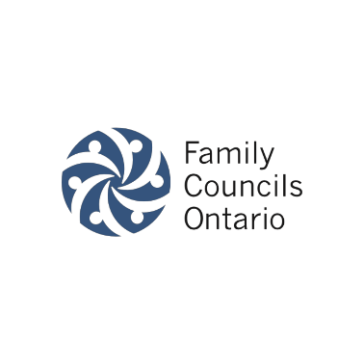
The Role of the Family Council Assistant

What is a Family Council Assistant?
Under the Fixing Long-Term Care Homes Act (2021), a Family Council can ask the management to appoint a Family Council Assistant. Individuals best suited for this role are trusted members of the home’s staff, commonly staff who are not primarily responsible for providing direct care to residents (i.e. Recreation Staff, Social Work, Spiritual Care, Resident & Family Services). Council Assistants are not members of the Family Council, but they do support the work of the Family Council.
Under the Act, a Family Council may request a home to appoint a Family Council Assistant to support the Council. The licensee (through its designate) shall then appoint a Family Council Assistant who is acceptable to the Council. 2021, s. 67 (1).
The Council Assistant takes direction from the Council, attending meetings (if invited), and maintaining confidentiality as required by the Council. 2021, s. 67 (2).

How does the Family Council Assistant support Family Councils?
Once appointed to the role, a Council Assistant should meet with the Family Council and discuss their role and responsibilities. Assistants should seek the approval of the Family Council in advance of any task they completed for or on behalf of the Family Council. Their main role is to make it easier for Family Councils to meet and work towards accomplishing their goals. To help in this task, Assistants can refer to the Family Council’s terms of reference. Some Family Councils choose to meet without their Council Assistant, while others may invite them to attend a certain portion of their meeting and will ask them to leave while the Family Council continues with their meeting.

Questions for Family Council Assistants to Consider
- Do you know if your home has an active Family Council?
- If so, do you know the name of the chair/president of the Family Council?
- What can you do to support the Family Cuncil at your home?

Questions for Family Councils to Consider
- Do you know who the Family Council Assistant at your home is?
- What information will you need to share with your Family Council Assistant to help them understand how they can support your Family Council? (i.e. Terms of Reference, Code of Conduct)
- How can your Family Council Assistant support your council's activities? (i.e. meetings, recruitment)

To learn more visit our website or contact us.
Toll Free: 1-877-622-9968
Phone: 647-427-5551
Website: www.fco.ngo
Email: info@fco.ngo

